Refunds

To make a refund, the order must be located in the SOP, and the order details screen displayed.

- Go to SOP
- Go to Orders

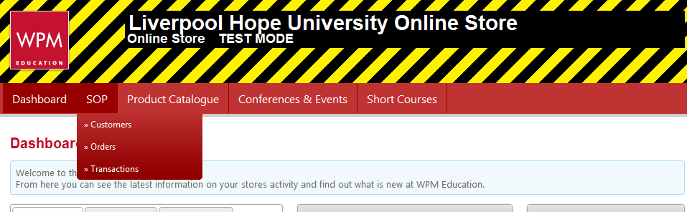

- Type in Order Number ( Click search)

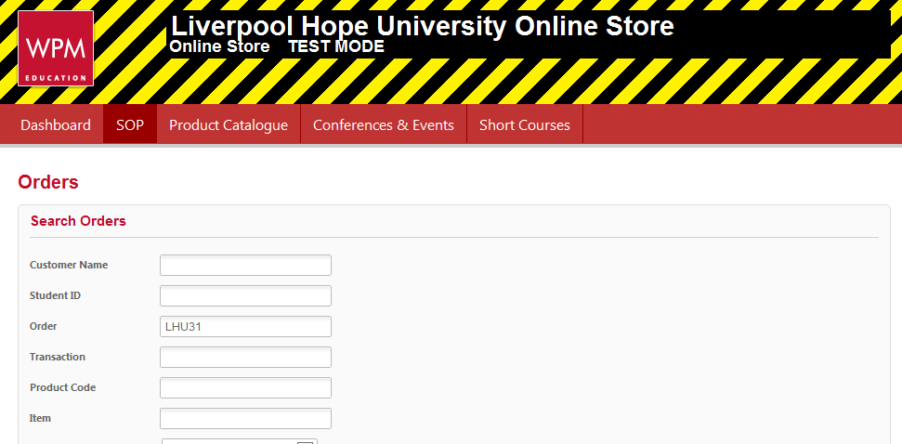

- Double Click anywhere on the Order below
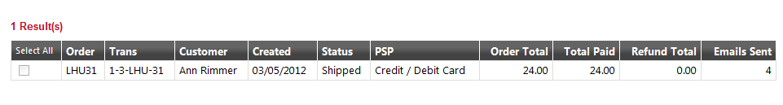

Simply tick the items that need refunding, and then use the Select Action drop-down, choose Refund and click the Update button:

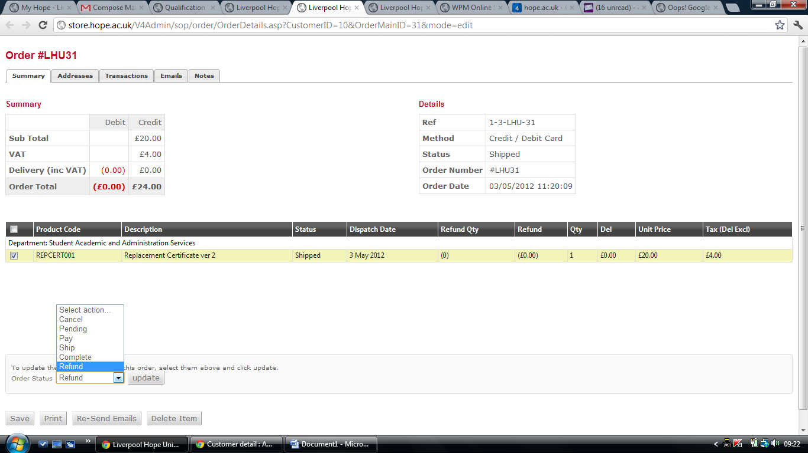

The Refund Items screen then allows you to set the amount (up to, but not greater than the item cost) and give a reason:

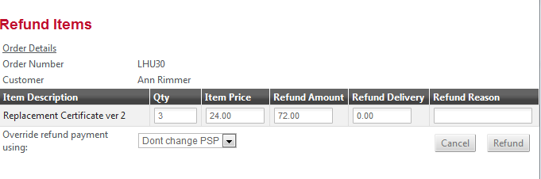

By default Don't change PSP is selected which means the payment will go back on the customer's card that made the original purchase. There is also the possibility of overriding the payment using Cash/Cheque if needed.

